# 1. Kano Categories Overview

| **Category** | **Definition** |
| --- | --- |
| Must-be | Basic expectations. If missing, user is dissatisfied. |
| One-dimensional | More = better. Directly impacts satisfaction. |
| Attractive (Delighter) | Unexpected but delightful features. Increases satisfaction when present. |
|  |  |

# 2. Requirement Classification Table

|  |  |  |  |  |
| --- | --- | --- | --- | --- |
| Feature | Description | Stakeholder | Category | Elicitation Method |
| Event-specific accommodations | Allows staff to manage and provide temporary arrangements for specific events. | Staff | Delighter | Brainstorming |
| Event integration | Syncs with the university’s event calendar to help users navigate event locations. | All Users | One-dimensional | Brainstorming |
| Offline map access | Enables users to access campus maps without an internet connection. | All Users | Must be | Brainstorming |
| Indoor building maps | Provides detailed floor maps of campus buildings to aid indoor navigation. | All User | Delights | Brainstorming |
| Elevator outage alerts | Sends real-time notifications about elevator outages affecting navigation. | All User | Delighter | Brainstorming |
| |  | | --- | | Accessible route planning |  |  | | --- | |  | | Provides optimized routes for users with disabilities, avoiding stairs and obstacles. | Users with disabilities | One-dimensional | Observing |

3.Finding

After conducting a brainstorming session with my team, we categorized the features as follows:

* Event-specific accommodations as a **Delighter**
* Event integration as **One-dimensional**
* Offline map access as a**Must-be**
* Indoor building maps as a **Delighter**
* Elevator outage alerts as a**Delighter**

After reviewing MMU’s online maps (e.g., GPS, official website) and physical infrastructure, I confirmed that elevators and ramps are available to assist users with disabilities in accessing classroom

* Accessible route planning as **One-dimensional**

Our Brainstorming Session

<https://youtu.be/PRHqW8USNLY>

[](https://youtu.be/PRHqW8USNLY)

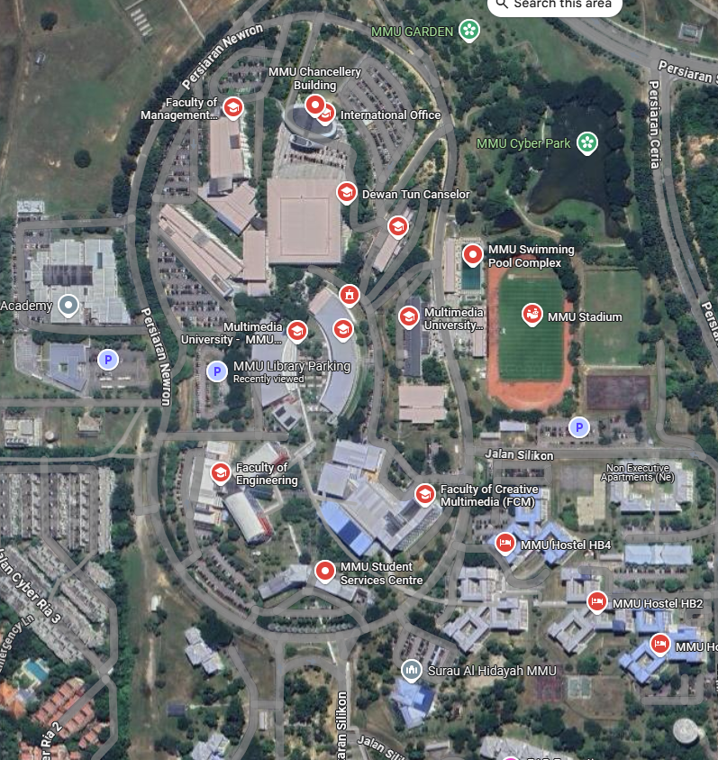

Image From Gps (MMU cyberjaya)

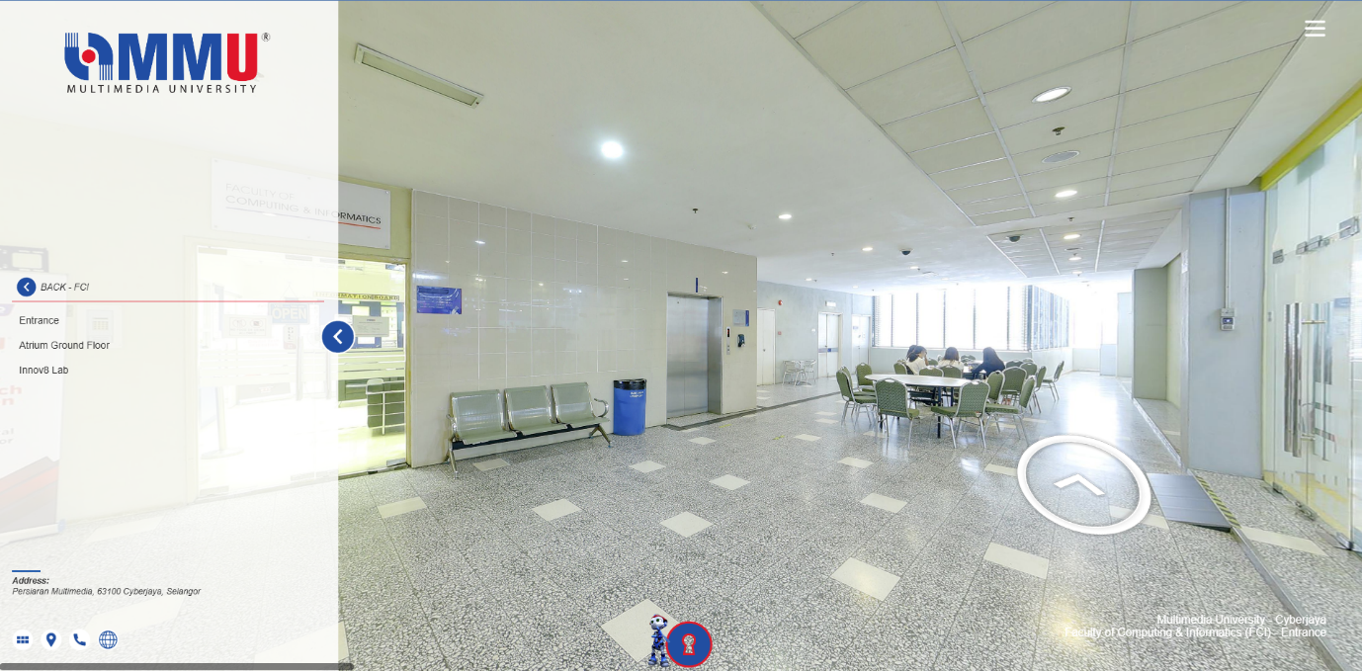<https://streetview.my/multimediauniversity/>

Can view FCI MMU Cyberjaya

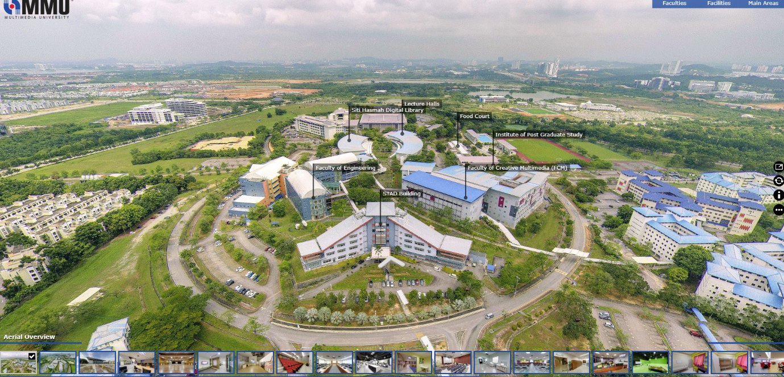<https://360vr.my/mmucyberjaya/>

Can view whole MMU Cyberjaya

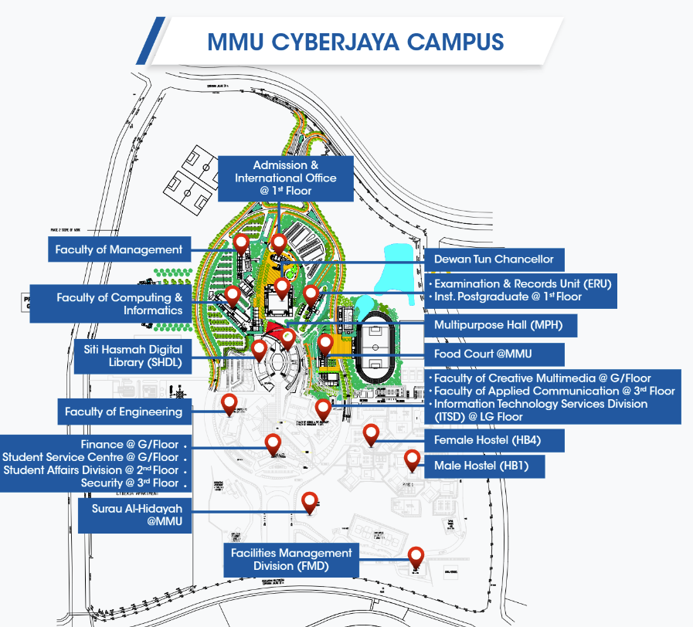<https://winprogramme.mmu.edu.my/wp-content/uploads/2020/11/cyberjaya.pdf>

Can view whole MMU Cyberjaya

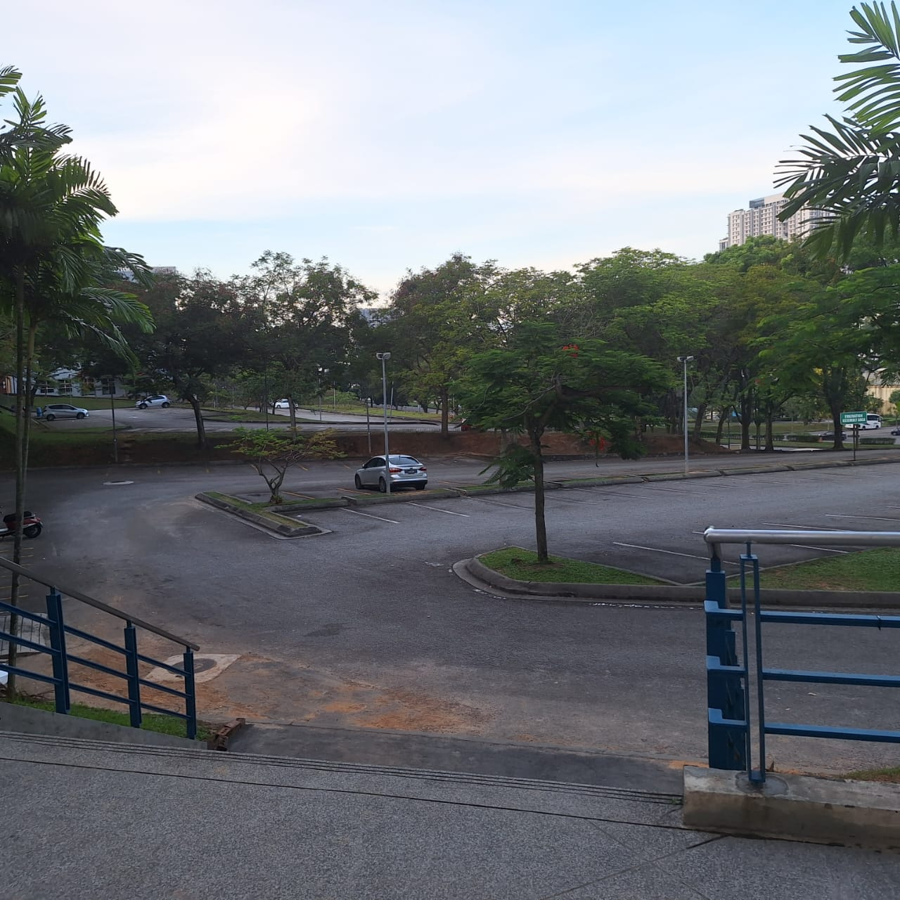FCI MMU Cyberjaya Parking Area

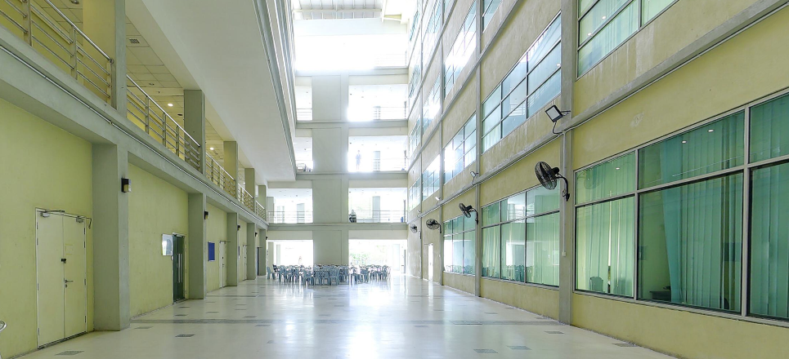

FCI MMU Cyberjaya ground floor hallway

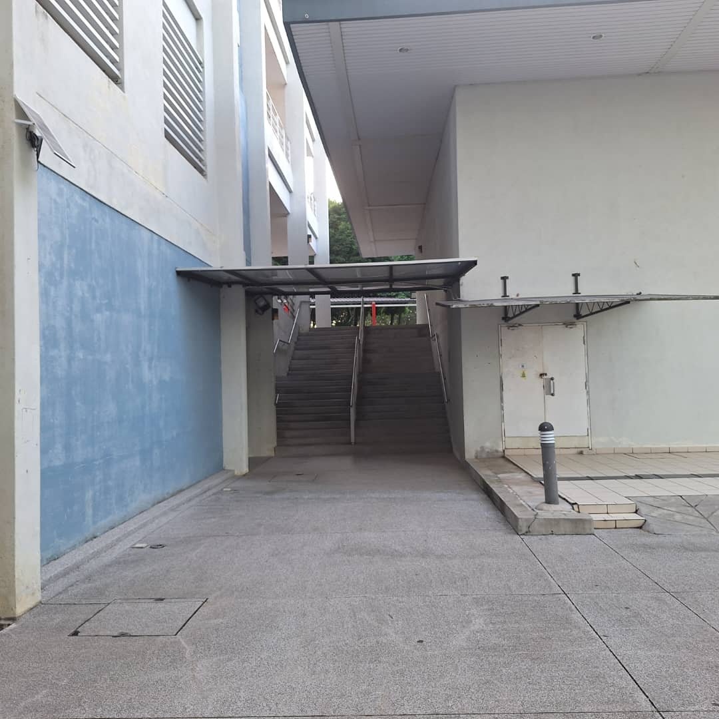FCI MMU Cyberjaya Staircase to 1st floor

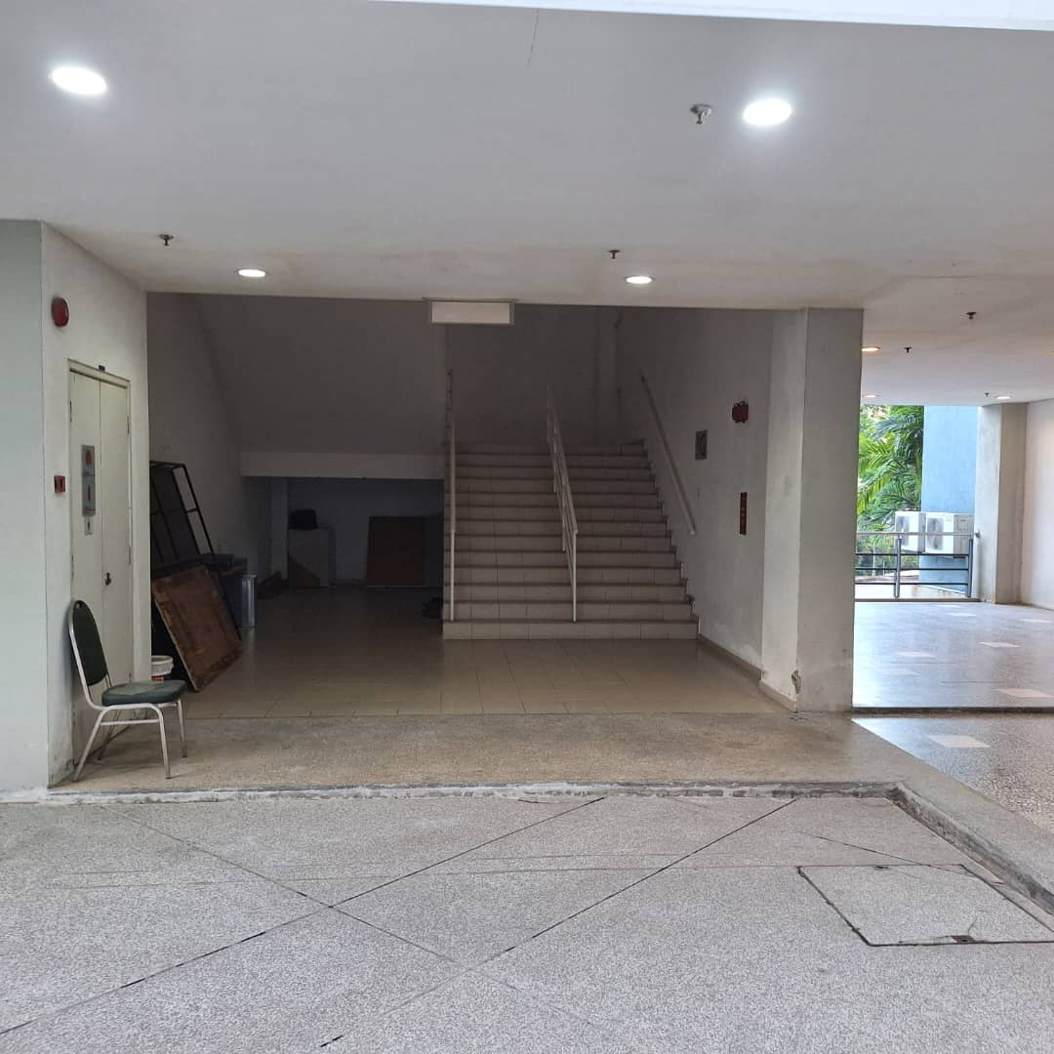

FCI MMU Cyberjaya Staircase to 1st floor

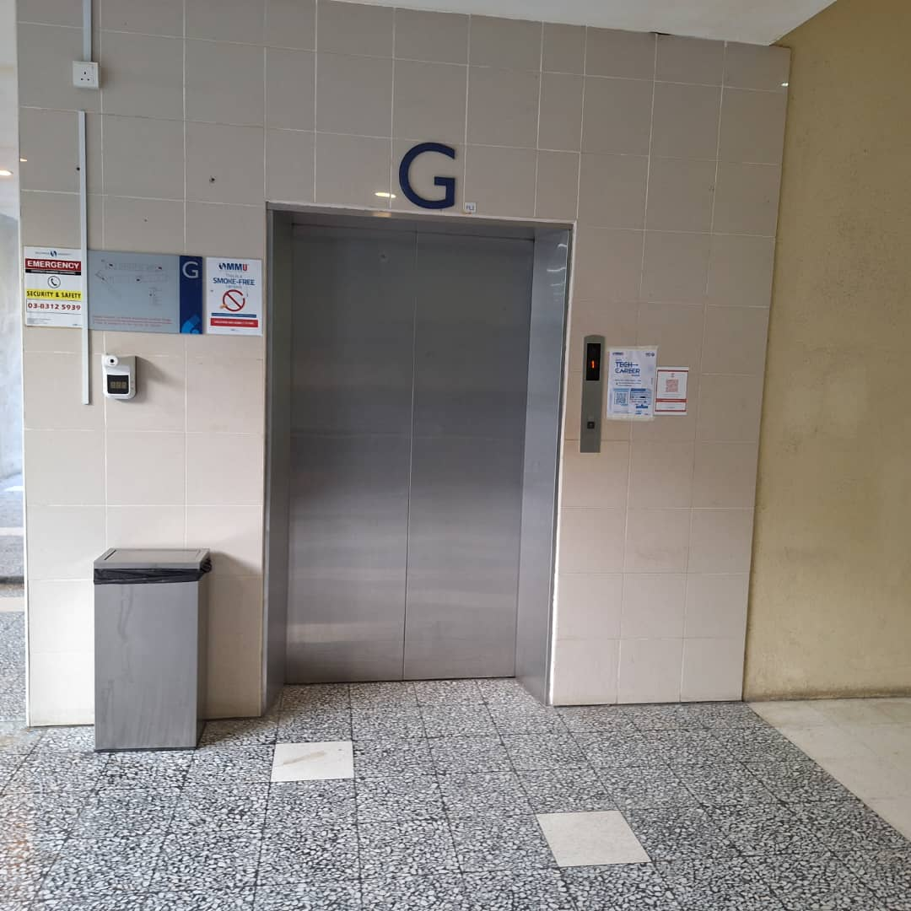One of the two elevators at FCI MMU Cyberjaya is on the FCI ground floor

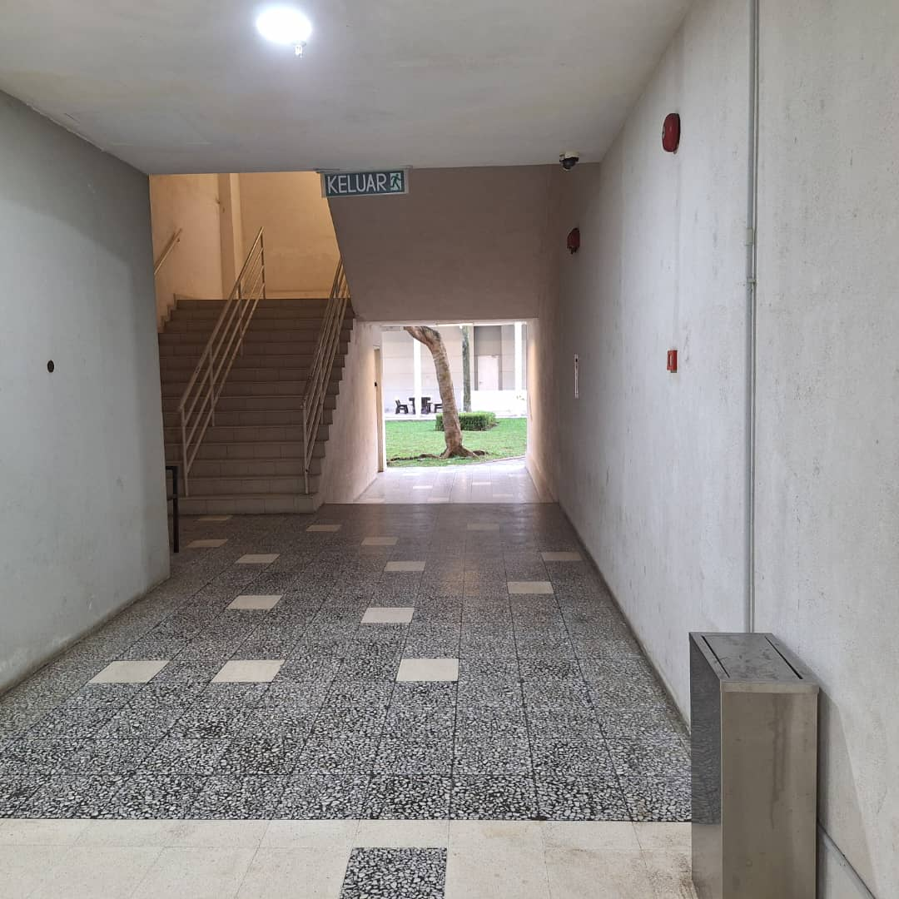FCI MMU Cyberjaya Staircase to 1st floor

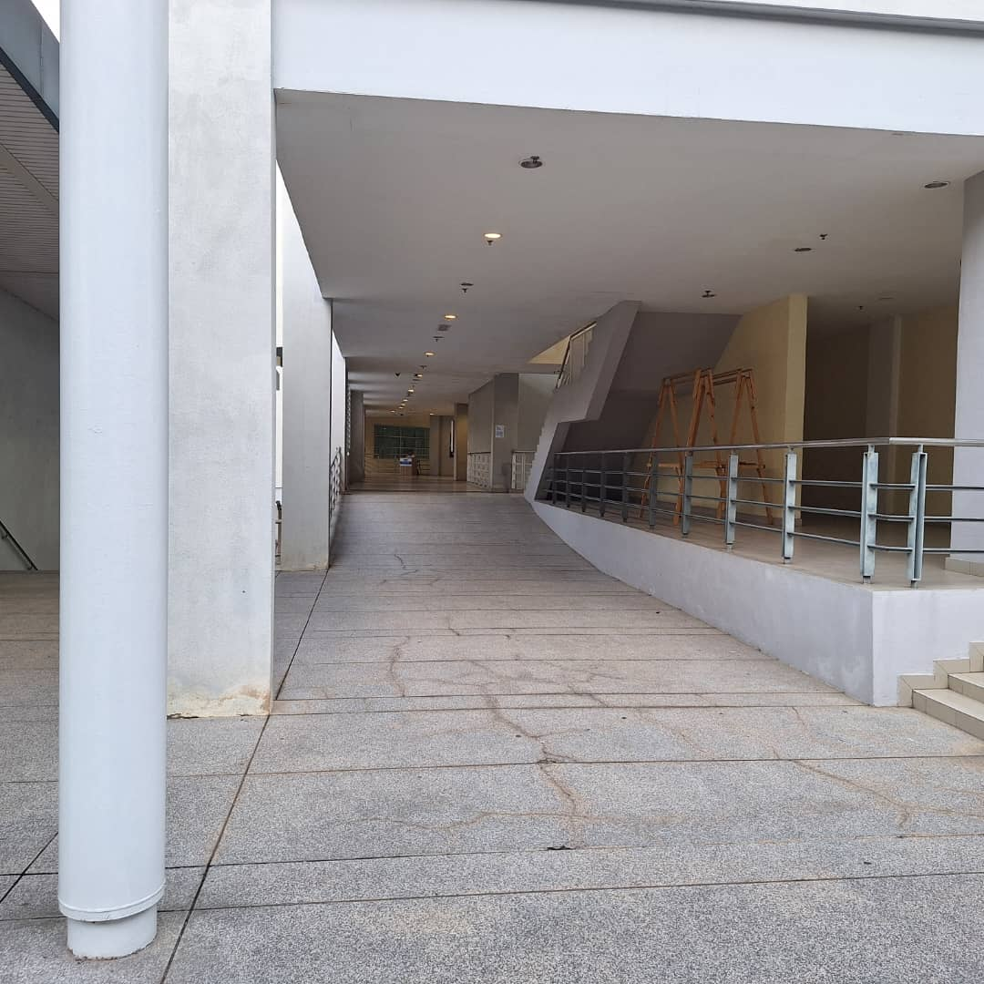

MMU Cyberjaya 1st to FCI facility

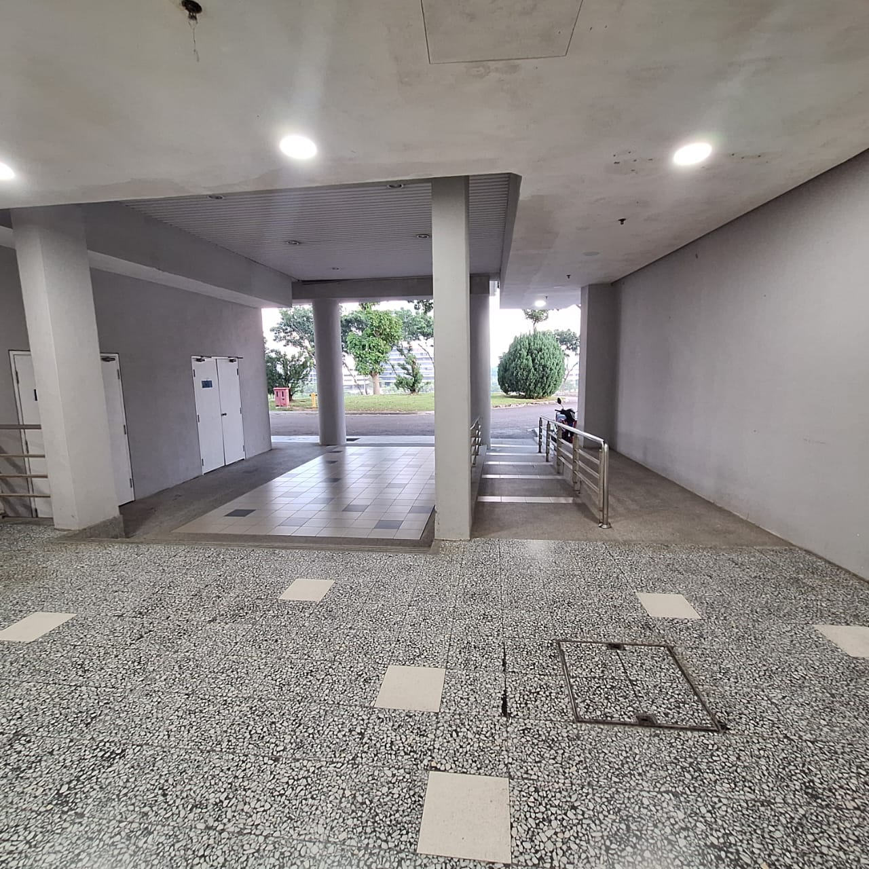

MMU Cyberjaya waiting area to FCI facility